ShopEasy, an online retail business, is facing reduced customer engagement and conversion rates despite launching several new online marketing campaigns. They are reaching out to you to help conduct a detailed analysis and identify areas for improvement in their marketing strategies.

**Key Points:**

* **Reduced Customer Engagement:** The number of customer interactions and engagement with the site and marketing content has declined.
* **Decreased Conversion Rates:** Fewer site visitors are converting into paying customers.
* **High Marketing Expenses:** Significant investments in marketing campaigns are not yielding expected returns.
* **Need for Customer Feedback Analysis:** Understanding customer opinions about products and services is crucial for improving engagement and conversions.

**Marketing Manager** at ShopEasy. We’ve been facing some challenges with our marketing campaigns lately, and I’m reaching out to request your expertise in data analysis to help us identify areas for improvement. Despite our increased investment in marketing, we’ve observed a decline in customer engagement and conversion rates. Our marketing expenses have gone up, but the return on investment isn’t meeting our expectations. We need a comprehensive analysis to understand the effectiveness of our current strategies and to find opportunities to optimize our efforts. We have data from various sources, including customer reviews, social media comments, and campaign performance metrics. Your insights will be invaluable in helping us turn this situation around.

**Customer Experience Manager** at ShopEasy, and I’m writing to seek your help with analyzing our customer feedback. Over the past few months, we’ve noticed a drop-in customer engagement and satisfaction, which is impacting our overall conversion rates.

We’ve gathered a significant amount of customer reviews and social media comments that highlight various issues and sentiments. We believe that by thoroughly analyzing this feedback, we can gain a better understanding of our customers' needs and pain points.

Your expertise in data analysis will be crucial in helping us decode this feedback and provide actionable insights. We hope this will guide us in improving our customer experience and ultimately boost our engagement and conversion rates.

**Increase Conversion Rates:**

**Goal:** Identify factors impacting the conversion rate and provide recommendations to improve it.

**Insight:** Highlight key stages where visitors drop off and suggest improvements to optimize the conversion funnel.

**Enhance Customer Engagement:**

**Goal:** Determine which types of content drive the highest engagement.

**Insight:** Analyze interaction levels with different types of marketing content to inform better content strategies.

**Improve Customer Feedback Scores:**

**Goal:** Understand common themes in customer reviews and provide actionable insights.

**Insight:** Identify recurring positive and negative feedback to guide product and service improvements.

**Data**

A database file MADB.Pak, Contains 6 Tables:

1. Products

ProductID ProductName Category Price

1 Running Shoes Sports 223.75

1. Customers

CustomerID CustomerName Email Gender Age GeographyID

1 Emma Anderson em @exl.com Male 50 2

1. Geography

GeographyID Country City

1 UK London

1. Customers Journey

JourneyID CustomerID ProductID VisitDate Stage Action Duration

1 64 18 2024-06-10 Checkout Drop-off 156

1. Customers Reviews

ReviewID CustomerID ProductID ReviewDate Rating ReviewText

1 77 18 2023-12-23 3 Average experience, nothing special.

1. Engagement Data

EngagementID ContentID ContentType Likes EngagementDate CampaignID ProductID ViewsClicksCombined

1 39 Blog 190 2023-08-30 1 9 1883-671

this is our data structure with example.

**Data Cleaning and Preparation:**

**SQL:**

1. **Products**

Products categorized upon price: Low price <50, Medium Price between 50 and 200, and High price >200

1. **Customers Table and Geography Table**

customer data completed by using left joint between the two table on geographyID, the result we added country and the city to user

1. **Customers Reviews**

ReviewText Column standardized by ensuring the spaces between words (Replace two spaces with one space)

1. **Customer Journey**

For Ensuring the uniqueness of every journey, I used RowNumber() to achieve that. there were many null values for duration, I used average to fill these null values.

1. **Engagement Table**

separate ViewClicksCombaind into two tables, convert content type to uppercase and because we social media is our main focus we excluded the Newsletters content Type.

**Python:**

we asked to analyse sentiments python is the best tool for this, because It contain a library called NLTK (Natural Language Tool Kit), and we will download Vader Lexicon model to use it for sentiments analysis.

another library pyodbc used to connect python to database and gathering customer reviews table.

after calculating sentiments score, we **Categorized sentiments** using the score and the customer rating as the following:

* Positive: score >0.05 and rating >=4
* Mixed Positive: score >0.05 and rating =3, or socre <-0.05 and rating>3
* Mixed Negative: score >0.05 and rating <3, or socre <-0.05 and rating=3
* Negative: score <- 0.05 and rating <=2
* Neutral: score between 0.05 and -0.05 and rating 3

beside this we added another function to create a Sentiment Buckets:

* *score* >= 0.5: '0.5 to 1.0'  *# Strongly positive sentiment*
* 0.0 <= *score* < 0.5: '0.0 to 0.49'  *# Mildly positive sentiment*
* -0.5 <= *score* < 0.0: '-0.49 to 0.0'  *# Mildly negative sentiment*
* '-1.0 to -0.5'

after that I used pandas to merge these three columns: score, category and bucket. the new file exported as CSV file with the following formula:

ReviewID CustomerID ProductID ReviewDate Rating ReviewText SentimentScore SentimentCategory SentimentBucket

1 77 18 12/23/2023 3 xxxxxx. -0.3089 Mixed Negative -0.49 to 0.0

**Now we are ready to open POWER BI**

**Measures and Columns Created:**

1. Age Range Column Created 18-29, 30-40, 40-55, and +55
2. Conversion Rate % (View/Purchased)
3. Total visit
4. Drop off % (Drop-off/total visits)
5. Engagement Rate (Likes/Views)
6. CTR - Click Through Rate (clicks/views)
7. Average Rating
8. Average sentiment score
9. Number of Campaigns

The Dashboard Divided into 4 pages:

1. Overview
2. Conversion
3. Engagement
4. Review

**Overview**

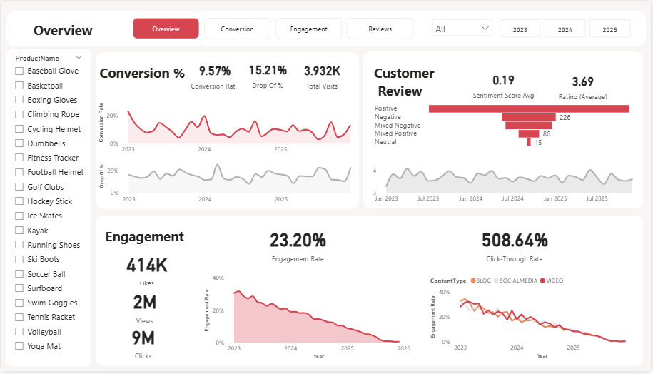

**Conversion**

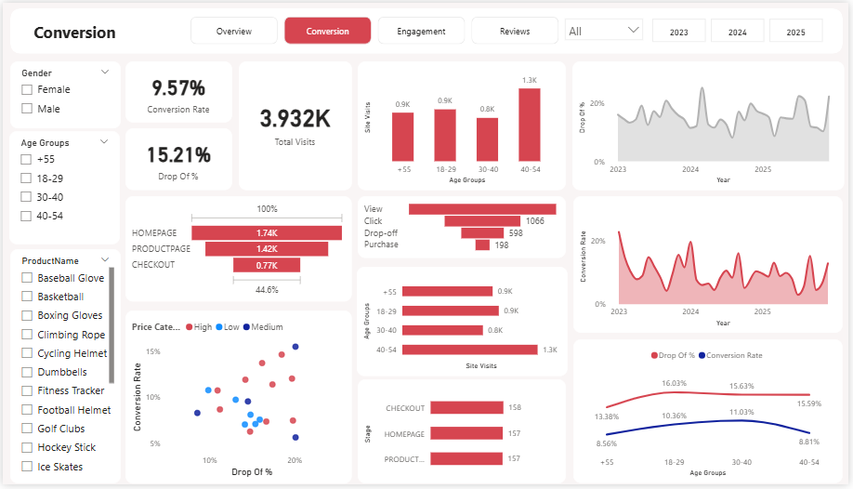

**Engagement**

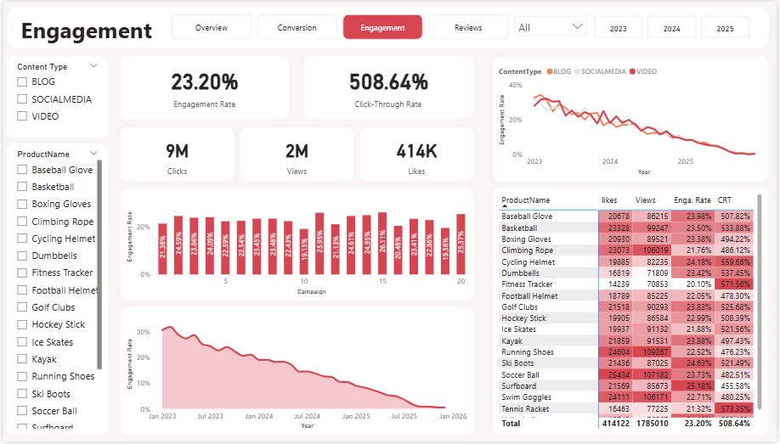

**Customer Reviews**

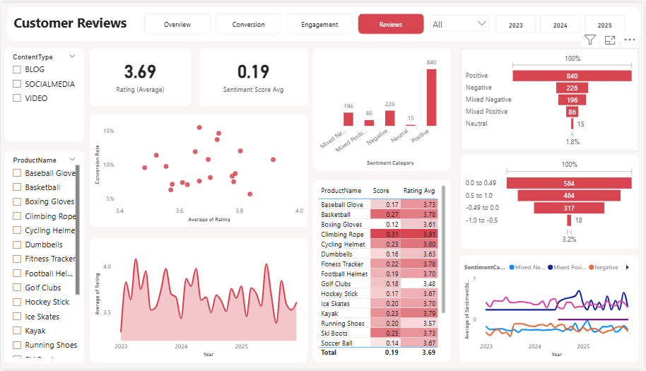

**Overall Business Performance**

* **Declining Performance:** All major performance indicators—conversion rate, drop-off rate, and engagement rate—have been on a consistent downward trend since early 2023.
* **Current State:** The current overall conversion rate is **9.57%**, and the engagement rate is **23.20%**, both of which have significant room for improvement.

**Conversion Insights**

* **Major Bottleneck at Checkout:** The most critical finding is the high drop-off rate of **44.6%** at the checkout page. This indicates a major point of friction in the customer journey that is directly impacting sales.
* **Demographic Differences:** The **18-29** age group has the highest drop-off rate, suggesting potential issues with the user experience or marketing messaging for this specific demographic.
* **High Traffic, Low Conversion:** The business has a strong visitor base with **3.932K** total visits, but these visits are not translating into sales at the desired rate, particularly at the final stage of the funnel.

**Engagement Insights**

* **Declining Engagement Rate:** The engagement rate has dropped significantly over the past three years, indicating that marketing content is becoming less effective at holding customer attention.
* **Content Type Performance:** The engagement rate for **Blog** content is performing very poorly. While **Social Media** and **Video** content have slightly better engagement, they are also showing a declining trend.
* **High Click-Through Rate:** Despite the declining engagement rate, the click-through rate is very high at **508.64%**. This suggests that marketing campaigns are effective at generating initial interest and getting users to click, but the content or site experience is failing to retain their interest.

**Customer Feedback & Satisfaction Insights**

* **Mixed Customer Sentiment:** The average customer rating is **3.69**, and the average sentiment score is **0.19**, indicating a mix of positive and negative feedback. While most reviews are positive, there are a significant number of mixed or negative reviews that need to be addressed.
* **Product-Specific Issues:** Several products have a lower average rating than the overall average, with **Golf Clubs** and **Kayak** having particularly low ratings. This points to specific product-level issues that are contributing to customer dissatisfaction.

### o the Marketing Manager

Your concerns about high marketing expenses and a decline in engagement and conversions are well-founded and clearly visible in the data. My recommendations are focused on optimizing your current spend and strategy for better returns.

1. **Prioritize Conversion Rate Optimization (CRO) at the Checkout Stage:**
   * **Insight:** The conversion dashboard highlights a critical issue: a **44.6% drop-off rate at checkout**. This is the single biggest point of friction and directly impacts your ROI.
   * **Recommendation:** Immediately launch a project to conduct a full audit of your checkout process. Look for potential roadblocks such as:
     + Lack of guest checkout options
     + Limited payment methods
     + Complex or lengthy forms
     + Unexpected shipping costs or fees
     + Slow page loading times
   * **Expected Outcome:** A small improvement in this drop-off rate will have a significant positive impact on your total conversion rate and revenue, making your marketing spend much more effective.
2. **Rethink Your Content Strategy:**
   * **Insight:** The engagement dashboard shows a dramatic decline in the overall engagement rate, driven largely by the poor performance of **Blog** content.
   * **Recommendation:** Stop or significantly reduce investment in blog content and reallocate that budget to more effective channels. Increase your focus on **Social Media** and **Video** content, which are showing better, though still declining, engagement. Experiment with new formats, interactive elements, or short-form videos to reverse the downward trend.
   * **Expected Outcome:** By focusing on what works, you can improve customer engagement and ensure your content marketing budget is being used efficiently.
3. **Optimize Campaigns Based on Performance:**
   * **Insight:** The campaign-level data shows varying engagement rates.
   * **Recommendation:** Use this data to identify your top and bottom-performing campaigns. Allocate more budget to the most effective campaigns and either pause or completely redesign the underperforming ones. Implement an A/B testing strategy for new campaigns to ensure they are optimized from the start.

### To the Customer Experience Manager

Your focus on understanding customer feedback is crucial, as it provides the context behind the numbers. The review dashboard offers a wealth of actionable data to improve satisfaction and, in turn, engagement and conversions.

1. **Conduct a Deep Dive into Low-Rated Products:**
   * **Insight:** The dashboard shows that some products, like **Golf Clubs** and **Kayak**, have ratings and sentiment scores below the overall average of **3.69**.
   * **Recommendation:** Pull all customer reviews and comments specifically for these products. Categorize the feedback to identify common pain points (e.g., durability, size issues, misleading product descriptions, etc.). Share this information with the product development or procurement teams so they can make direct improvements or adjust the product descriptions to set clearer expectations.
   * **Expected Outcome:** Improving the products that are generating negative feedback will not only boost their individual ratings but also improve overall customer satisfaction and reduce return rates.
2. **Create a Feedback Loop with Marketing:**
   * **Insight:** The decline in engagement and conversion is linked to customer dissatisfaction.
   * **Recommendation:** Work with the marketing team to use customer feedback as a tool for new campaigns. For example, if a product consistently receives positive reviews for its durability, use that as a key selling point in the next marketing campaign. Conversely, if there are common complaints, ensure the marketing team addresses them proactively in content or product descriptions.
3. **Proactively Engage with Reviews:**
   * **Insight:** The significant number of "Mixed" and "Negative" reviews presents an opportunity.
   * **Recommendation:** Implement a process to respond to all mixed and negative reviews. Acknowledge customer pain points publicly and offer solutions. This shows that you are listening and can help to turn a dissatisfied customer into a brand advocate.

### Final Recommendation for All Stakeholders

The dashboards are most powerful when the insights are used collaboratively. I recommend establishing a regular, cross-functional meeting between the Marketing, Customer Experience, and Product teams. Use these dashboards as a shared source of truth to:

* Identify the root causes of underperformance.
* Prioritize initiatives based on data.
* Track the impact of changes over time.

By working together, you can transform these data points into a cohesive strategy for growth.